Section 9 flexbox

54 Display Flex

Early days tables and rows were used for styling. They are still used today but should be used for semantic reasons, like when it makes sense to show data in a table, not for styling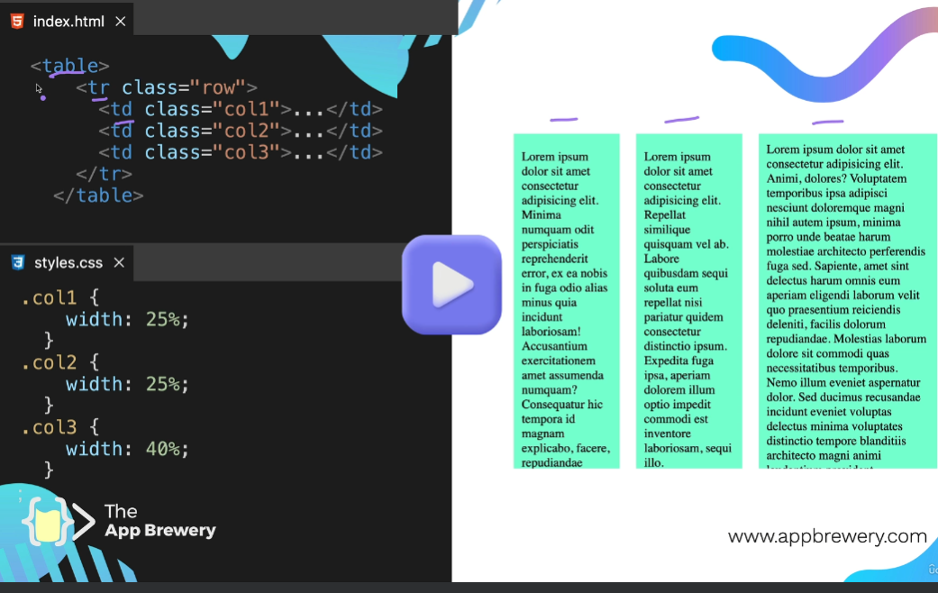

Then came the display features – inline block – not great because not aligned along the top

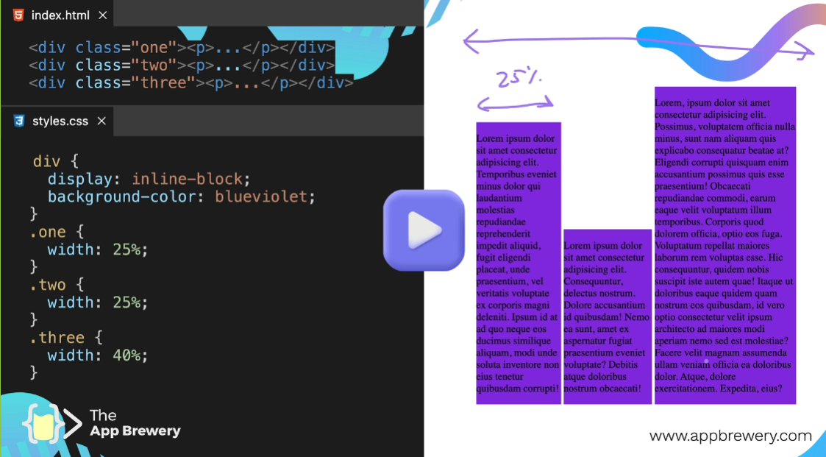

Position absolute gets the lined up along the top – not responsive not great

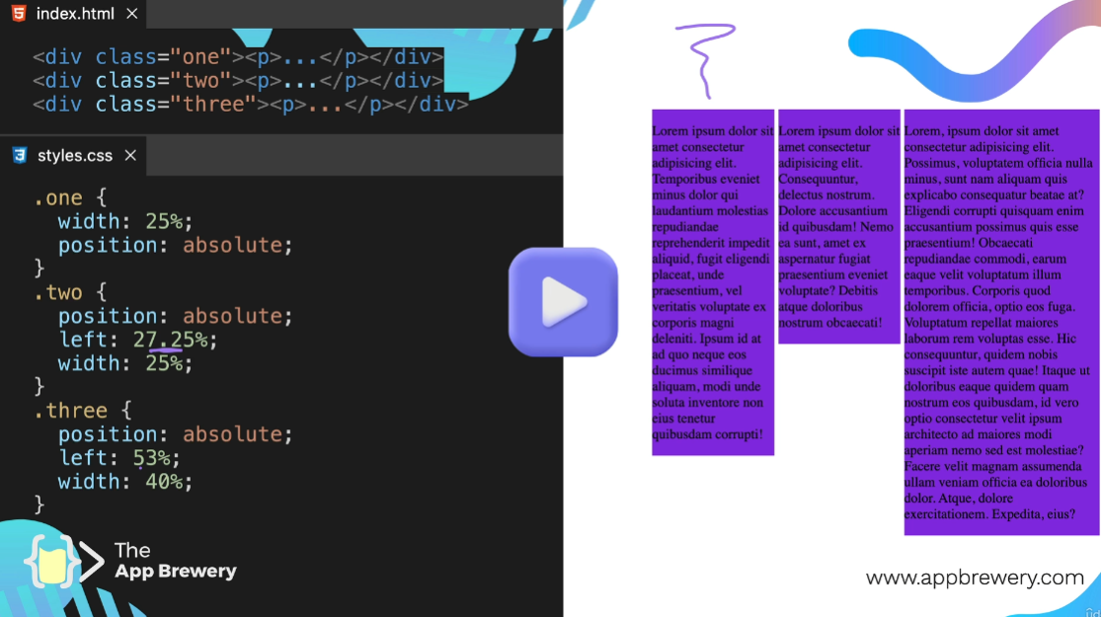

2005 – 2010 Float was popular – getting text around stuff and complex layout -

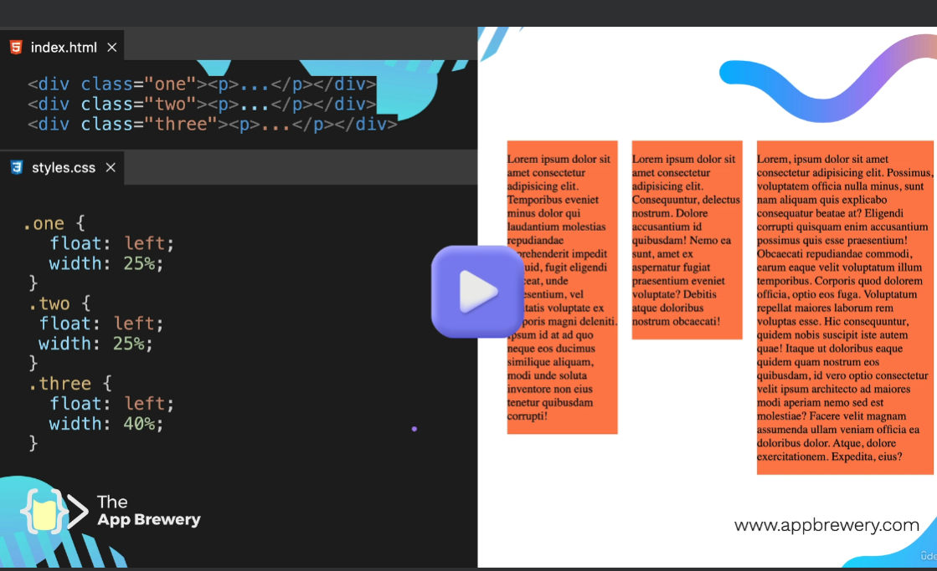

Gets very hacky and difficult

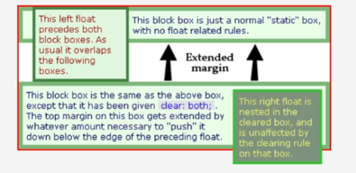

Use float to float an image to the left or right of a block of text but not for anything more complex

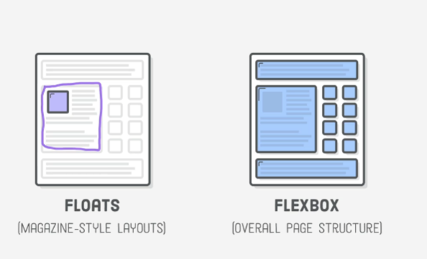

Flexbox – Grid – Bootstrap modern web layout methods

Can use floats inside of flexbox to wrap text if needed.

To use flexbox wrap divs inside a container , then on the container display is flex , the gap is the gutters between rows and columns

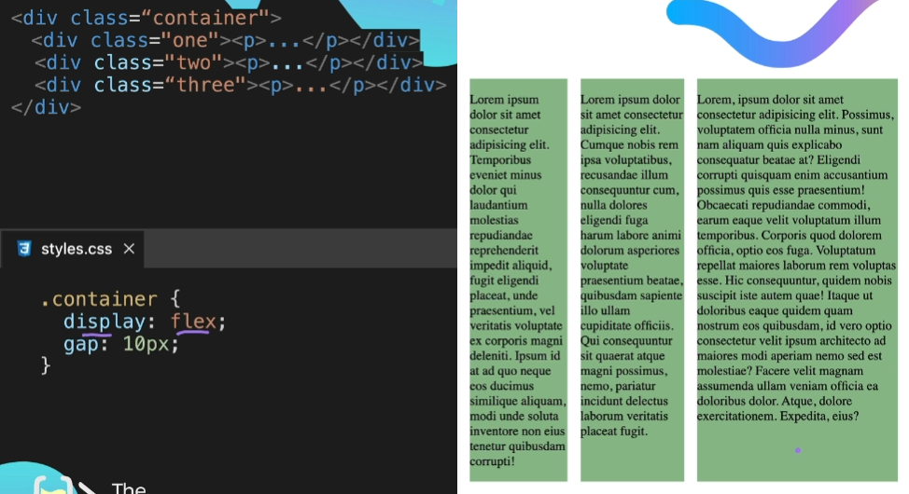

Flexbox is a different system so does not use inline,block,in-lineblock or none. 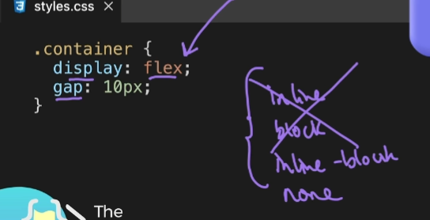

The stuff wrapped in flex box no longer has the default display values the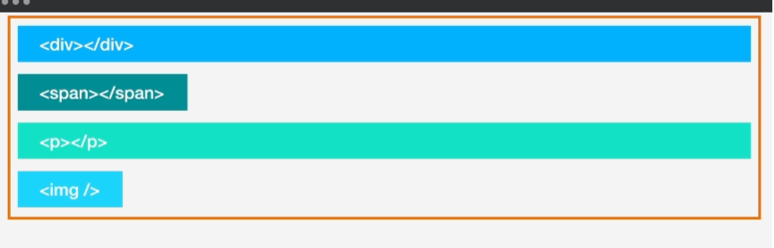

They use Flexbox display values , are layed out by flexbox

The width of the items in the flex box is usually dependent on width of the content 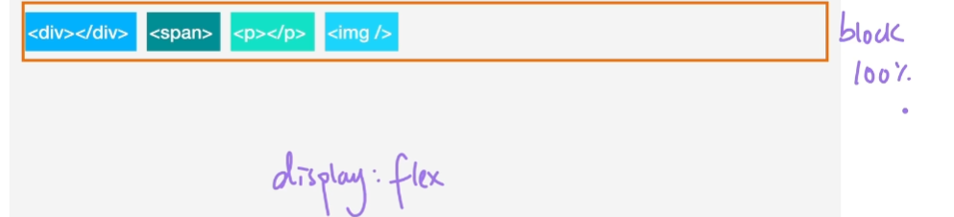

Display inline-flex

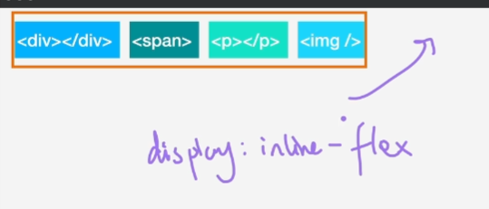

Ex

Make index.html look like this

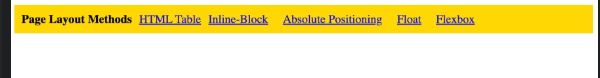

**55 Flex Direction**

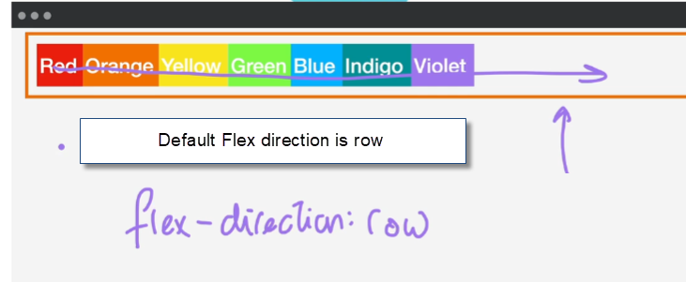

Default main axis is row L>R , cross axis goes perpendicular

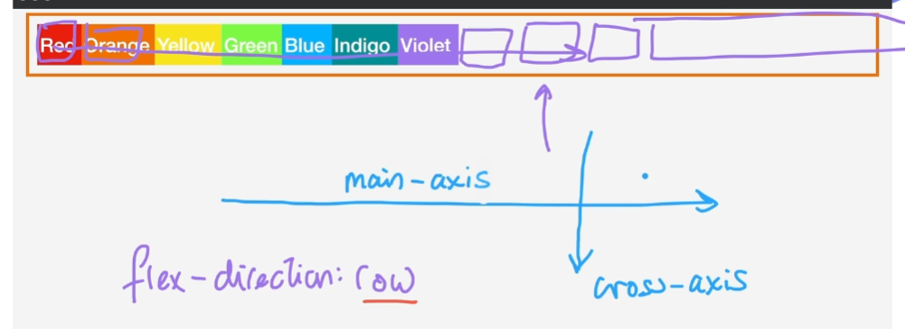

Now setting flex direction to column – it flexes along the default axes :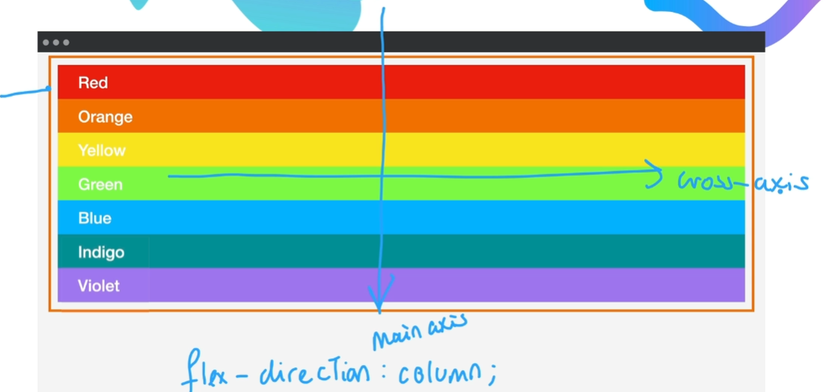

flex-basis: 100px would set the height if flex-direction is column but if flex-direction is row would set the width.

**56 Flex Layout** –

<https://css-tricks.com/snippets/css/a-guide-to-flexbox/>

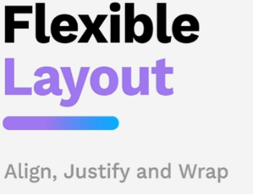

Align , justify and wrap

Note that the child vs parent can change layout a lot

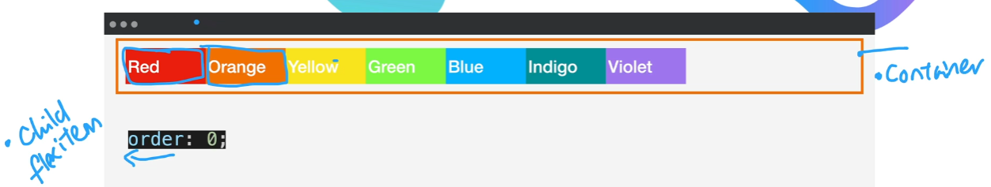

Use **order** to re arrange – by default it is 0

The largest number goes to far right 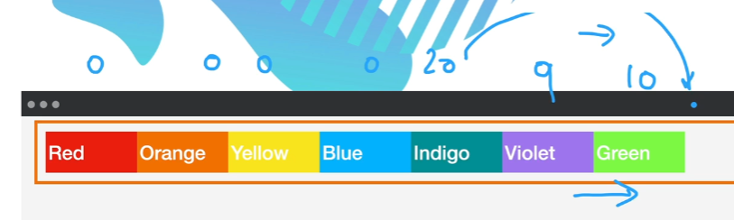

**flex-wrap: set this on the parent or the flex box container itself**

**default nowrap** -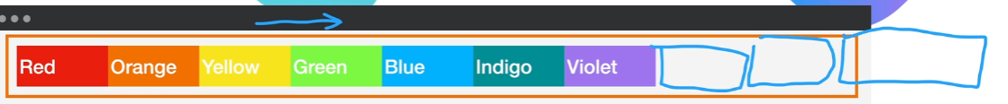

**wrap**

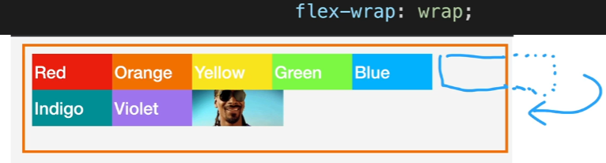

**wrap-reverse** - goes from bottom right corner to top left corner.

<https://appbrewery.github.io/flex-layout/>

justify-content: - is set on the parent, sets distribution of items along main axis – for row left to right column top to bottom.

The default is flex-start

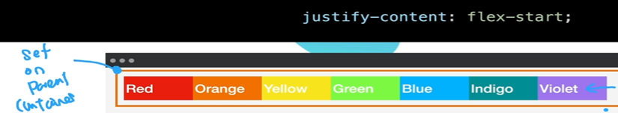

flex-end:

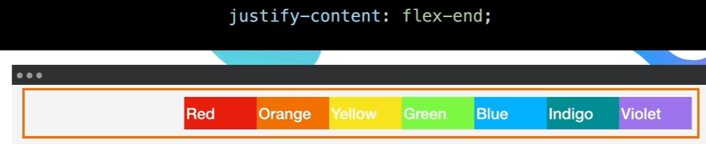

flex-center:

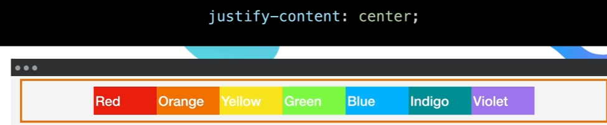

space-between:

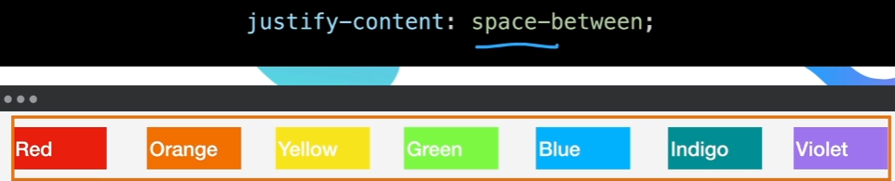

**align-items: set on the container , it sets the distribution along the cross axis**

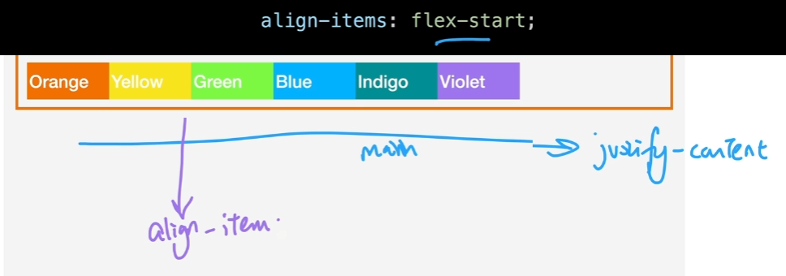

**For align-items to work need to set height on the container**

**flex-start –** bunch up to top

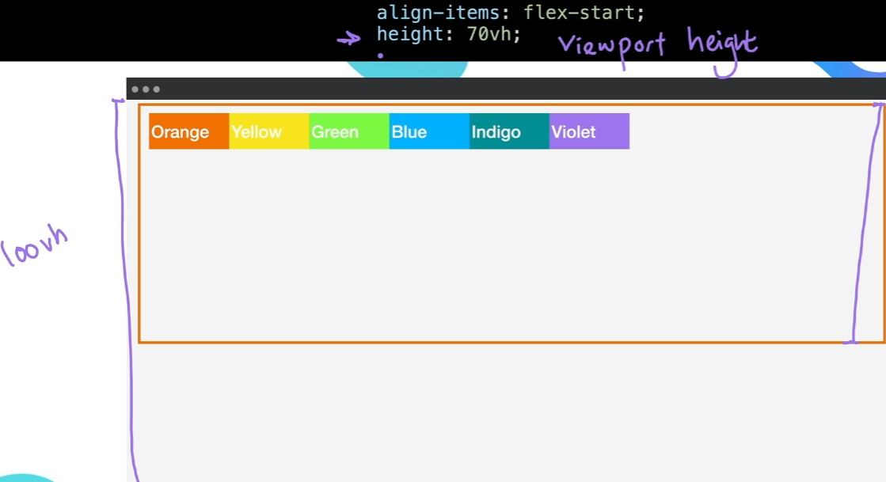

**flex-end –** bunches up to bottom

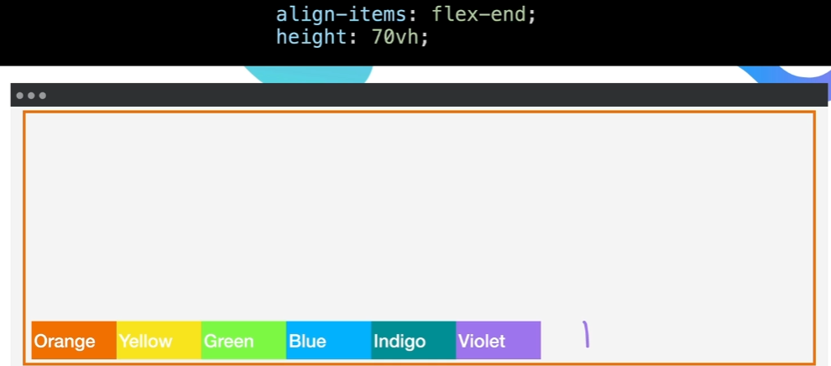

**center** to middle

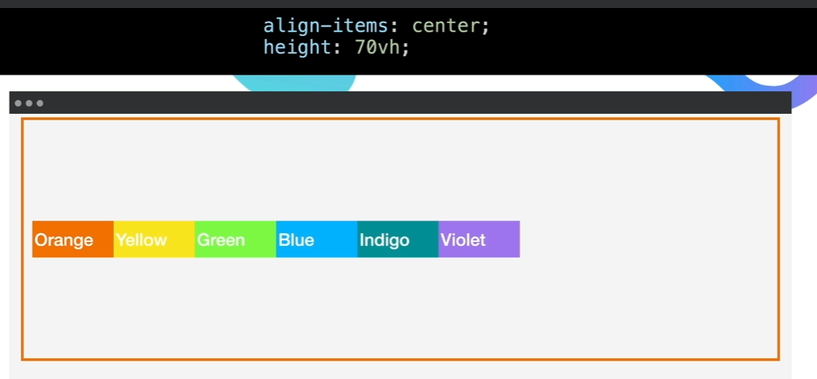

Flex Wrap impacts align items, for now setting to no wrap and things work as expected

To get the violet box to pop off by itself sent align-self: on it, the item

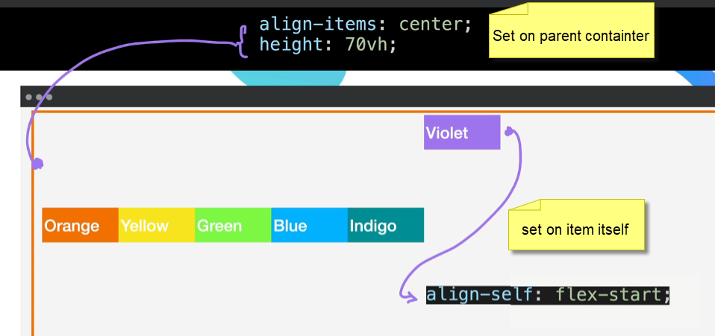

Use this guide – no memorizing

<https://css-tricks.com/snippets/css/a-guide-to-flexbox/>

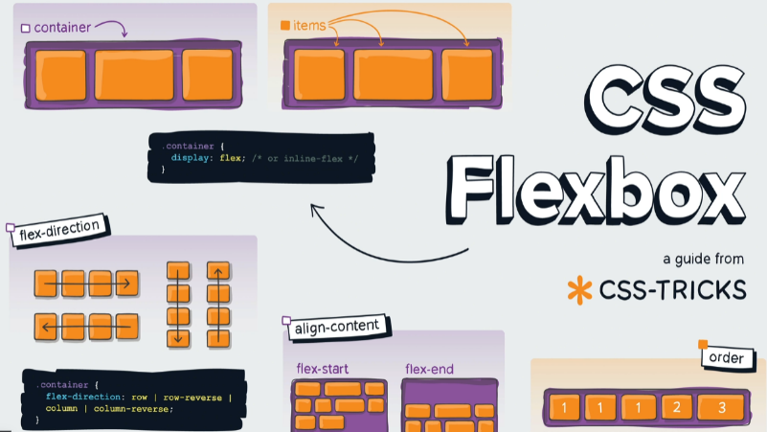

align-content: is similar to align-items:, but only works when flex-wrap: is set to wrap

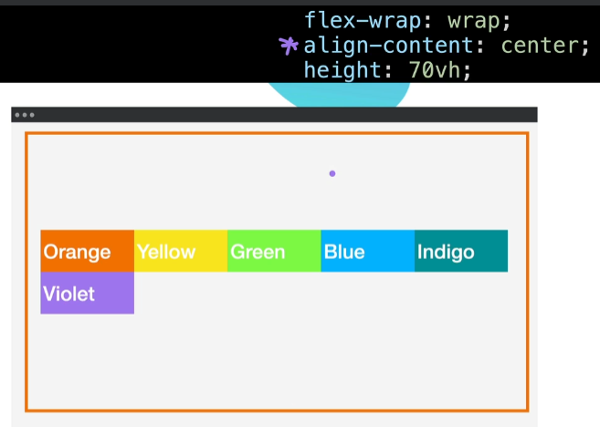

align-items: vs align-content:

-check the cheat sheet

Restart froggy game at level 14

Flexbox Froggy game - <https://appbrewery.github.io/flexboxfroggy/>

<https://css-tricks.com/snippets/css/a-guide-to-flexbox/>

<https://appbrewery.github.io/flex-layout/>

solutions

### Section 9: Flexbox - Flexbox Froggy Challenge ( FULL SOLUTION )

32 upvotes32

[Manoj](https://www.udemy.com/user/manoj-kumar-4355/) ·

Lecture 56

 · 10 months ago

**57 Flex Sizing** – shrink , grow , responsive – default works most of the time

The algorithm flex-box uses in priority

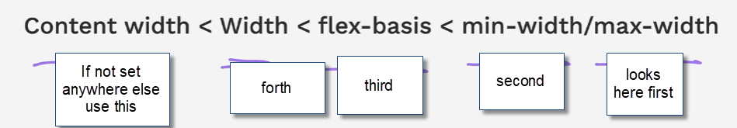

By default - Min width is the longest word – then scrolls off page

If a width is set then will shrink until it cannot then scrolls off page

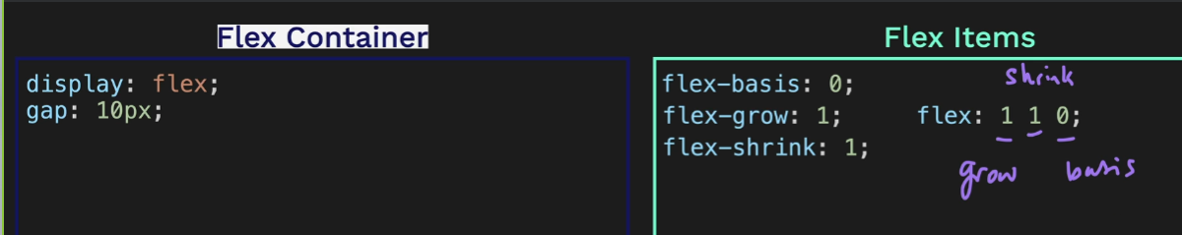

Or even shorter

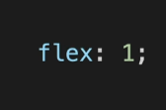

**58: Pricing Table project** -

Finished look at walk through

Restart here

<https://www.udemy.com/course/the-complete-web-development-bootcamp/learn/lecture/37368412#questions>